PIXELS

Interactive Web Application for Image Processing

November 28, 2018

Lokesh balani (20173073), abhishek tyagi (20173067)

PGSSP, IIITH

Contents

Introduction _____________________________________________________________________________________________01

Tool Description 03

Application Architecture and Development 13

Results ___________________________________________________________________________________________________14

Team Members 21

Project Milestones and Contribution 22

# Introduction

PIXELS is the project undertaken as a mandatory requirement for the course “Digital Image Processing”. The aim of the course is to provide introduction to the field of digital image processing, with the focus on fundamentals which would aid students in leveraging them for more advanced courses as well as in their research.

## puprpose of the document

In this document there is an overall description of the Web Application, PIXELS. It includes what we did. There is also description of the work experience gain from the project.

## intended audience

The intended audience for this document include professors/teachers teaching image processing, students learning image processing, project members, the teaching assistants, the users willing to leverage the application and the students/professionals willing to contribute to the project.

## problem statement

To create a Web-based interactive tool for demonstrating image processing techniques in real time to images provided by the user. The application should assist Professor in classroom and should also be modular and easily extensible.

## PROJECT PIVOT

The objectives of this project are:

1. The Web Application should be interactive and to be able to be used as a companion for lectures
2. The Web Application should be modular and easily extendible
3. The Web Application should have minimalistic design
4. The Web Application should be easy to use
5. The Web Application should be able to accept user images as input and generate real time output

## DELIVERABLES

The deliverables to be produced for this project include:

1. A web application
2. Project presentation
3. Github repository
4. Final project report

## github repository

<https://github.com/lokeshbalani/pixels>

# Tool Description

## User interface

The Web Application is very user friendly and intuitive and uses GUI Interface implemented in HTML, CSS & JavaScript on the Client Side and Django, Python on the Server Side.

Various features are self-explanatory and the modules can be easily added, updated and removed.

## FEATURES

* Intuitive Interface
* Minimalistic Design
* Interactive GUI
* Support for Image Drag-n-Drop
* Support for Image Upload from Local Computer
* Downloadable Images
* Accessible Image and Module Info
* Required Configurable Option Settings for the Processing Techniques
* Modular with ease-of-extension
* Clean separation of various modules to facilitate easy modification and revision
* Python Library(s) support
* Segmentation into **Lecture Companion** and **Do It Yourself** Interface

## architecture

* Django provides the basic platform. It starts a local web server, defines the URL patterns, binds the model and the view, and provides backend integration with python libraries
* The Image Processing Modules are written in Python using the libraries like OpenCV, etc. wherever necessary.
* The webpages have been created using the Django Templating Engine
* The Front End Code/Page View, Interface and Interaction has been coded using HTML/CSS/JavaScript/jQuery.

## Running the Webapp (without virtualenv)

$git clone https://github.com/lokeshbalani/pixels.git

$cd pixels

$pip install -r requirements.txt

$python webapp/manage.py makemigrations

$python webapp/manage.py migrate

$sudo python webapp/manage.py runserver

## Running the Webapp (on virtualenv)

$git clone https://github.com/lokeshbalani/pixels.git

$cd pixels

$virtualenv py_env

$source py_env/bin/activate

$pip install -r requirements.txt

$python webapp/manage.py makemigrations

$python webapp/manage.py migrate

$sudo python webapp/manage.py runserver

When done deactivate/terminate the virtual environment

$deactivate

To install and setup python virtual environment refer to the below URL:  
<https://docs.python-guide.org/dev/virtualenvs/>

## Graphical USER interface

The Web Application will start on the following IP Address: <http://127.0.0.1:8000>

Web Application navigates to the main Landing Page of the application (see screenshots below)

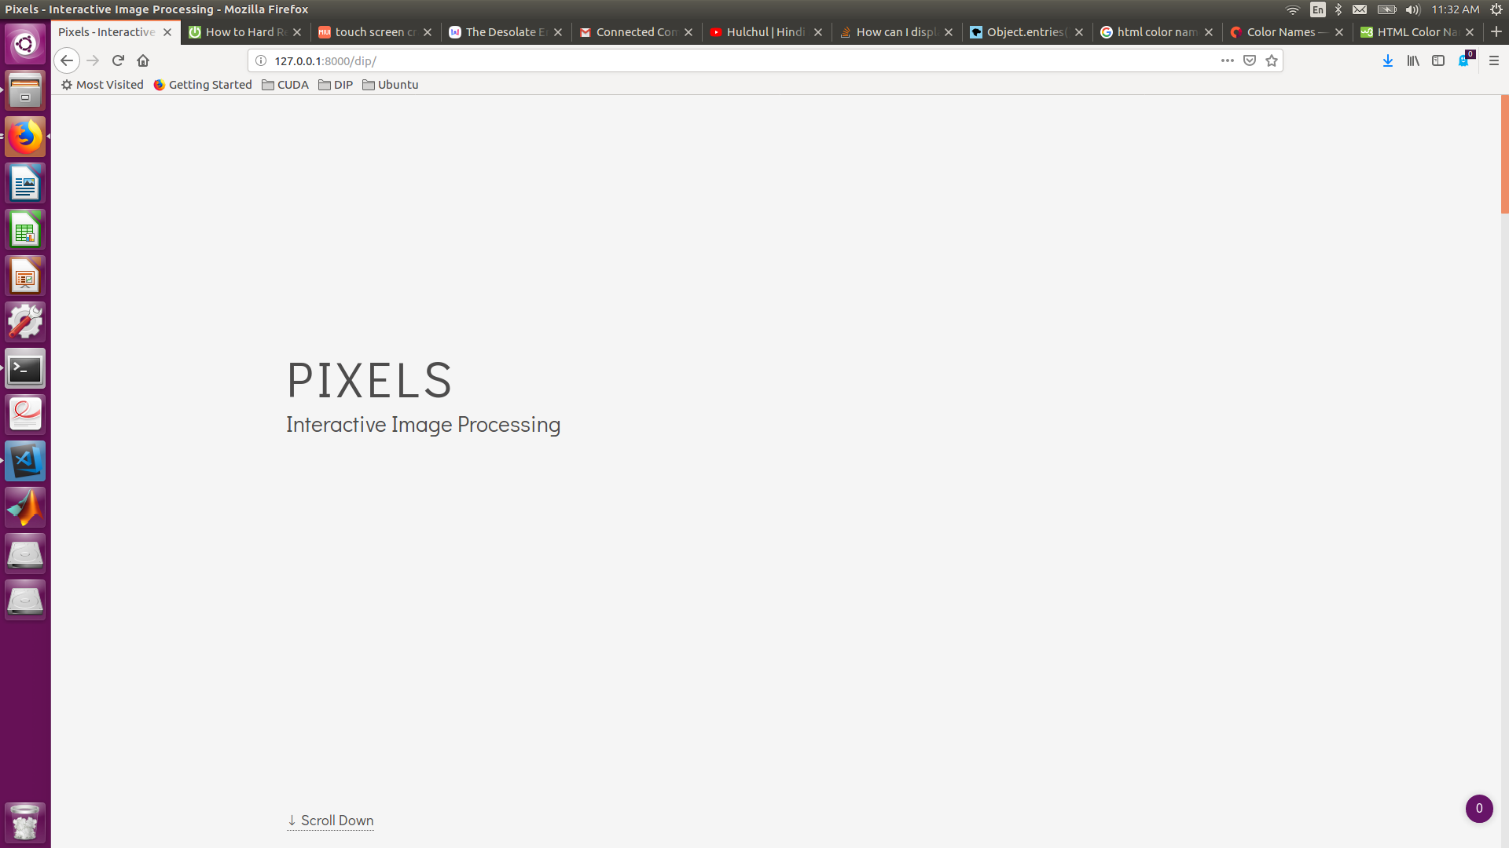

On Scrolling it displays the Modules implemented by the broad categorization (see below)

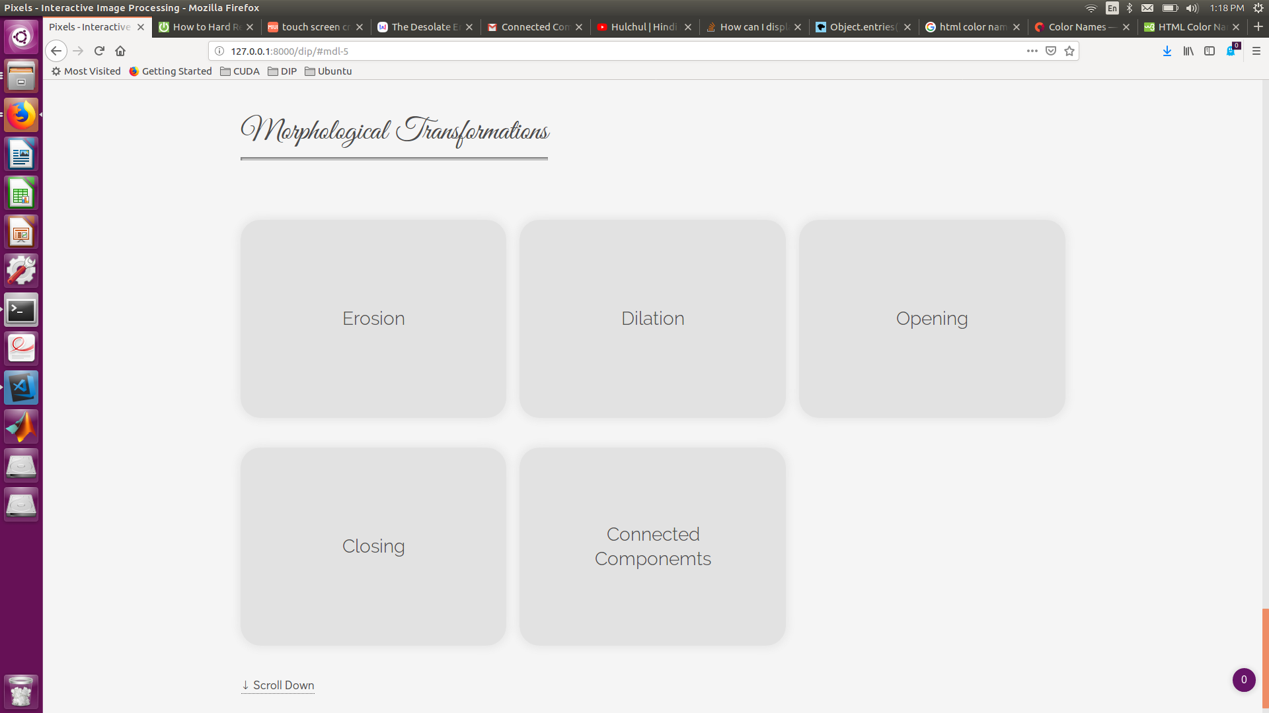

Clicking on the Individual Modules takes us to that Modules Page (see below)

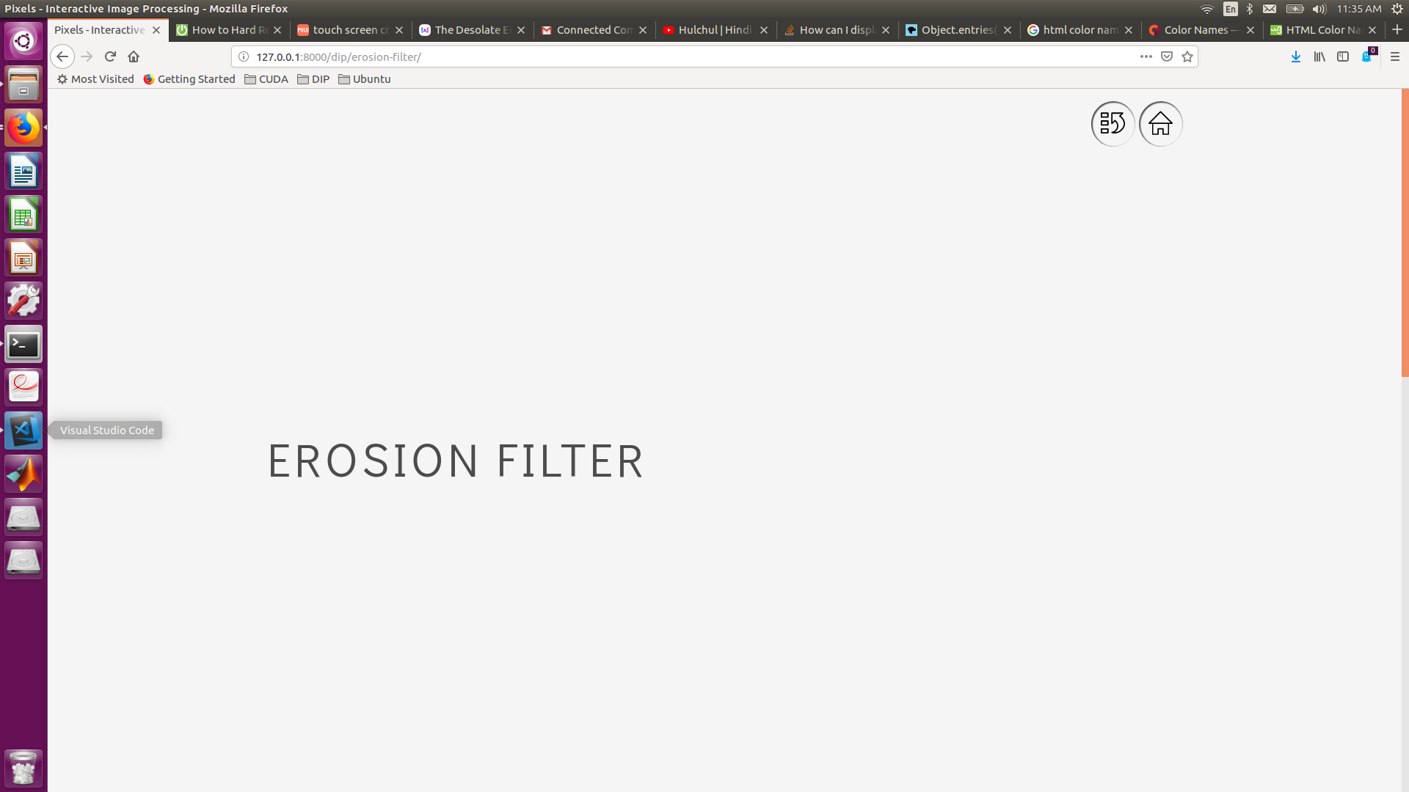

The Modules have two sections : Lecture Companion (for classroom demonstrations) and Do It Yourself

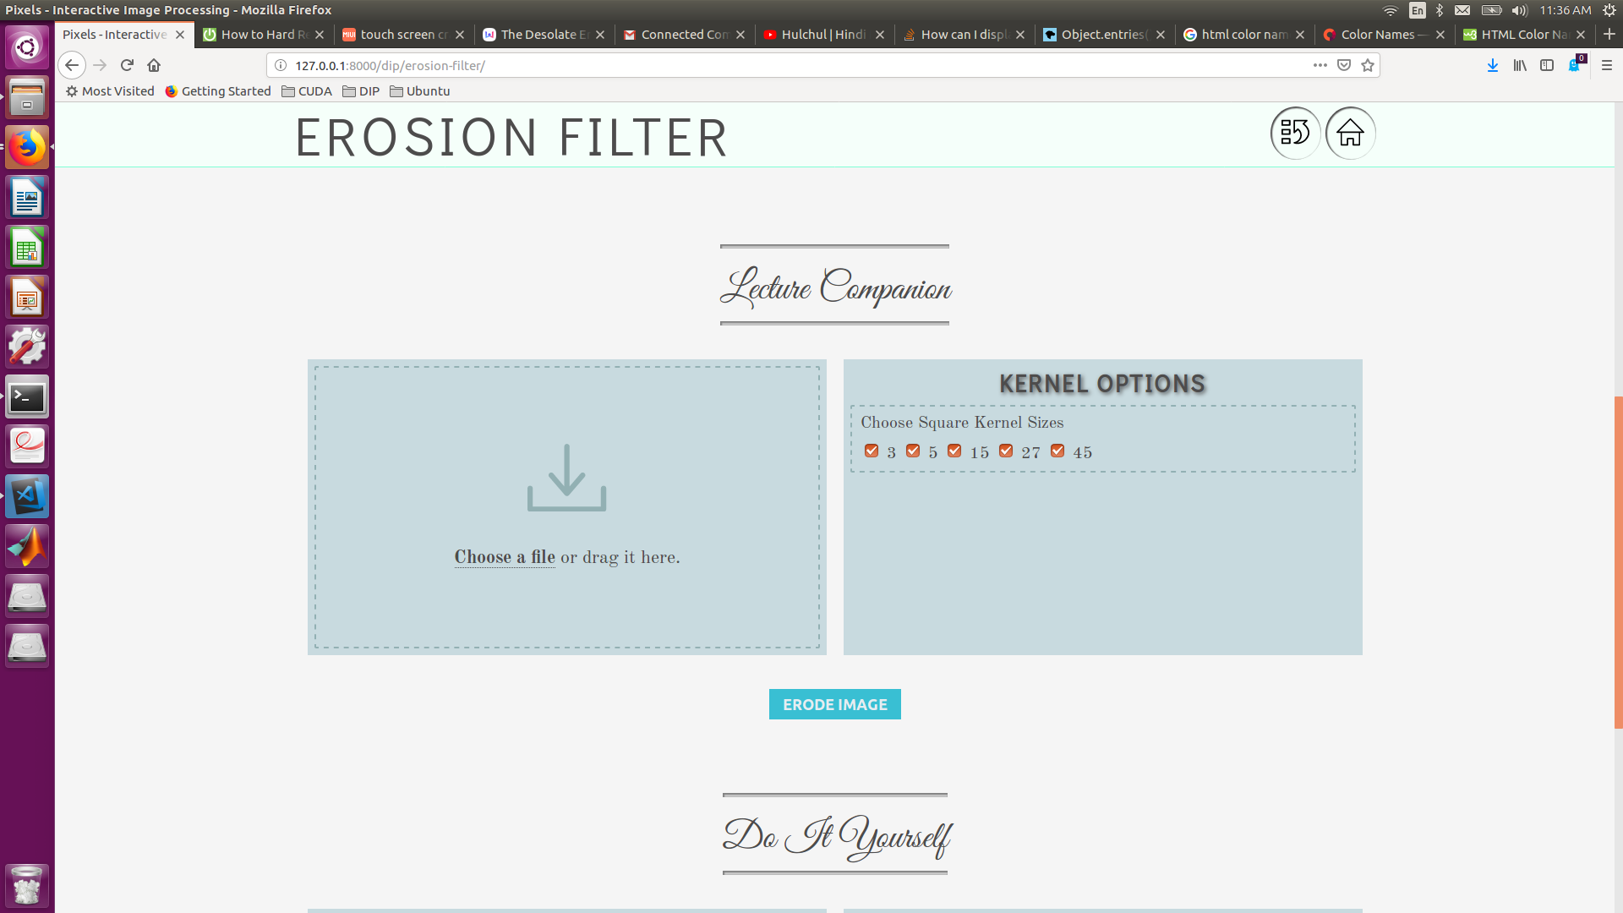

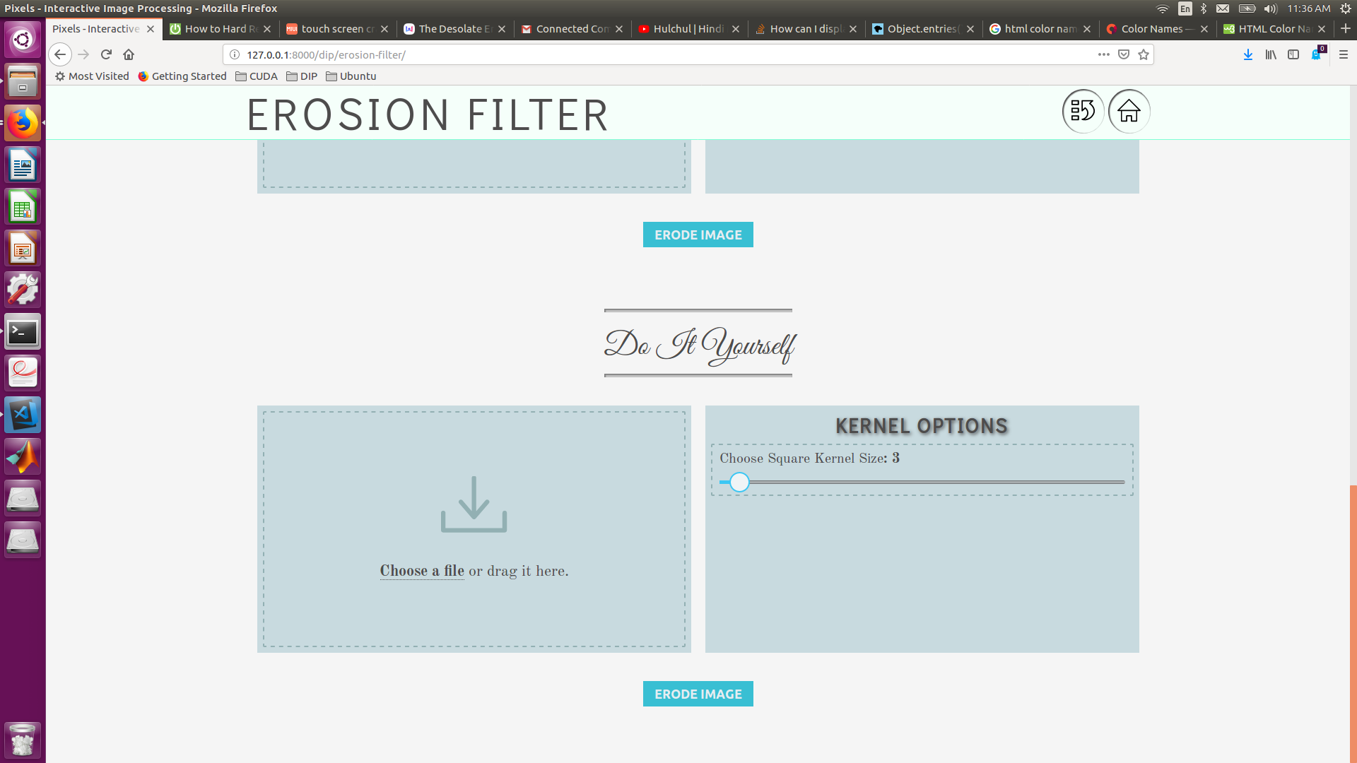

The right section shown above contains the parameters that can be set by user for the respective technique.

Click on **Choose File** option to select an Image from Local Computer, or Drag-n-Drop Image to the upload section on the left (see below)

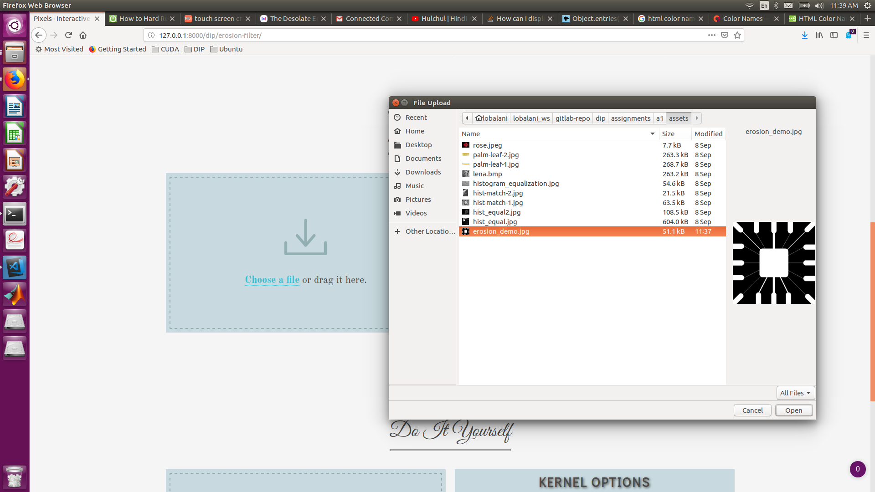

On selecting an input image, the preview of the image is rendered. The rendered image has the option to select a window to zoom to a particular part of image as shown below:

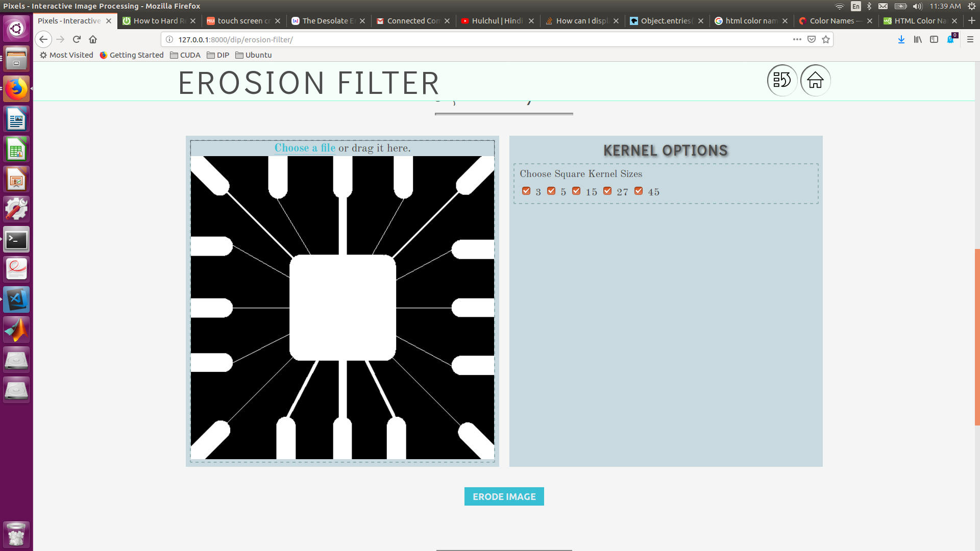

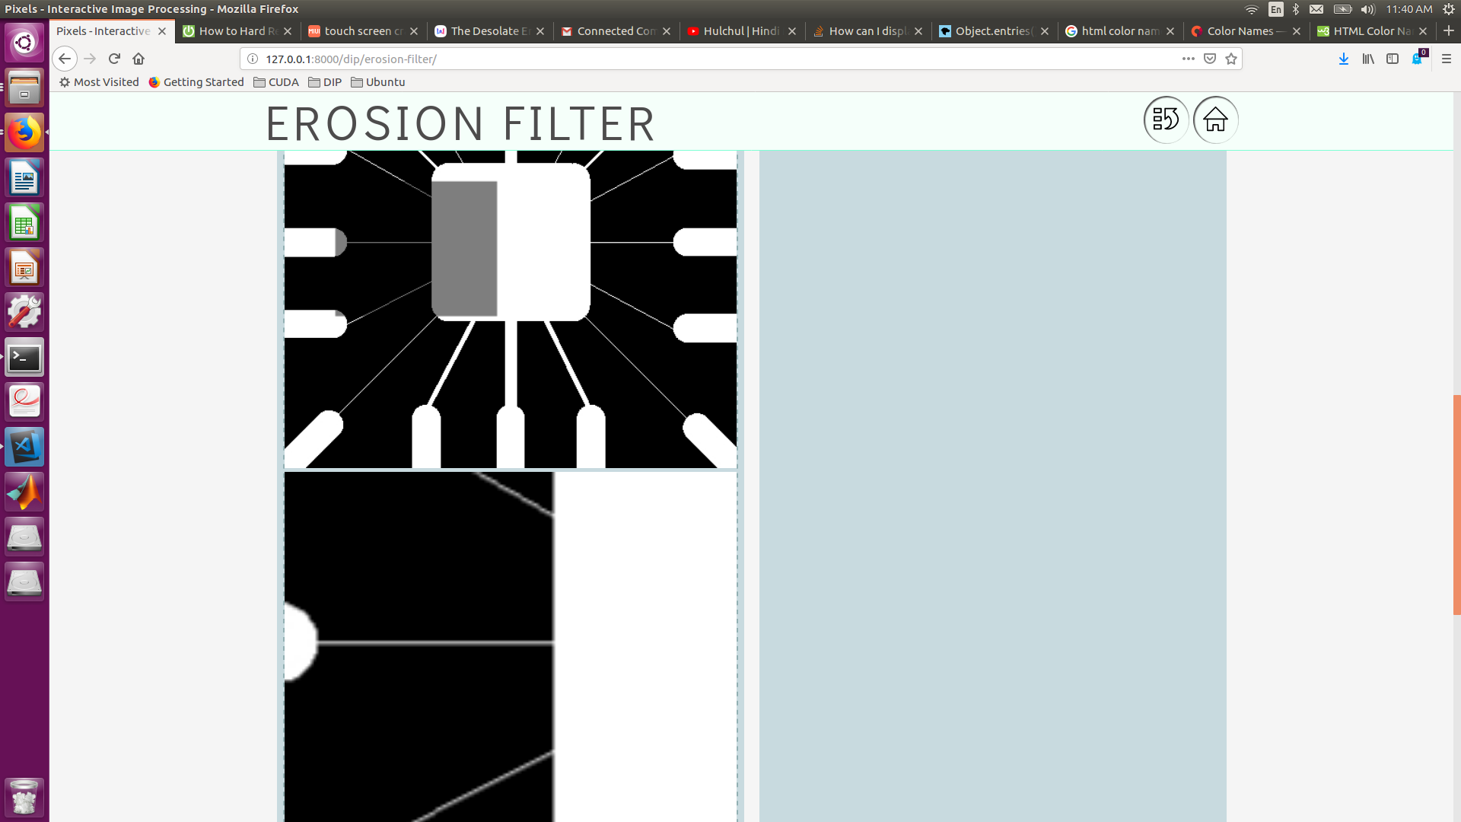

Clicking on the ERODE IMAGE button generates the output eroded image along with the image and processing info as shown below

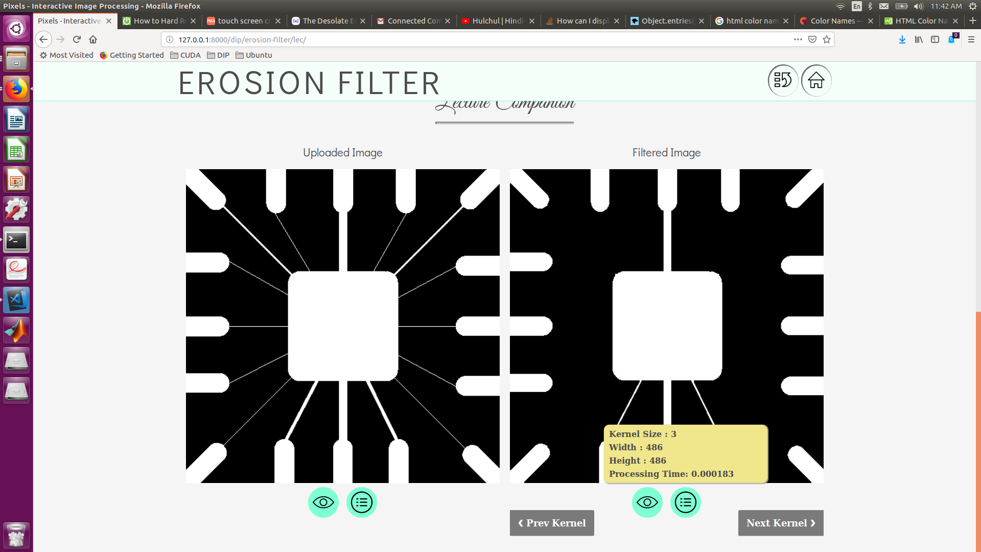

By Clicking on the preview Icon the Image can be downloaded.

Clicking on the Next Kernel or Previous Kernel Option generates the Image Output for the next kernel defined in the settings list.

Select Zoom functionality has been implemented for the Output Images as well.

The Modules can also be implemented so that the output can be shown in steps as it has been implemented for **Connected Components** (as shown below)

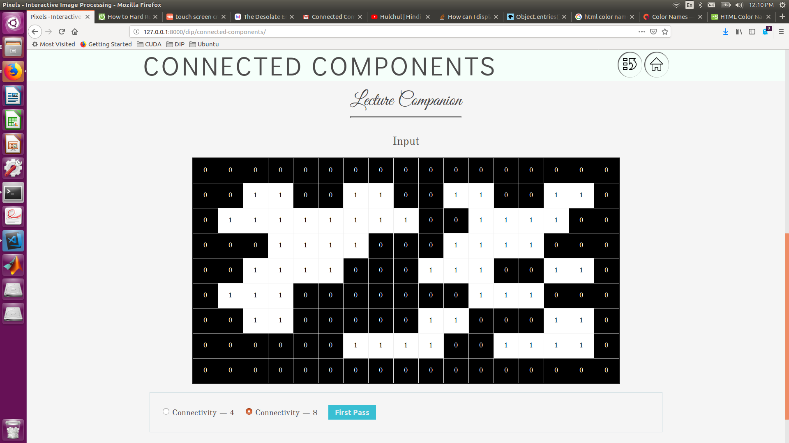

The Cells in the Input matrix are editable (see below)

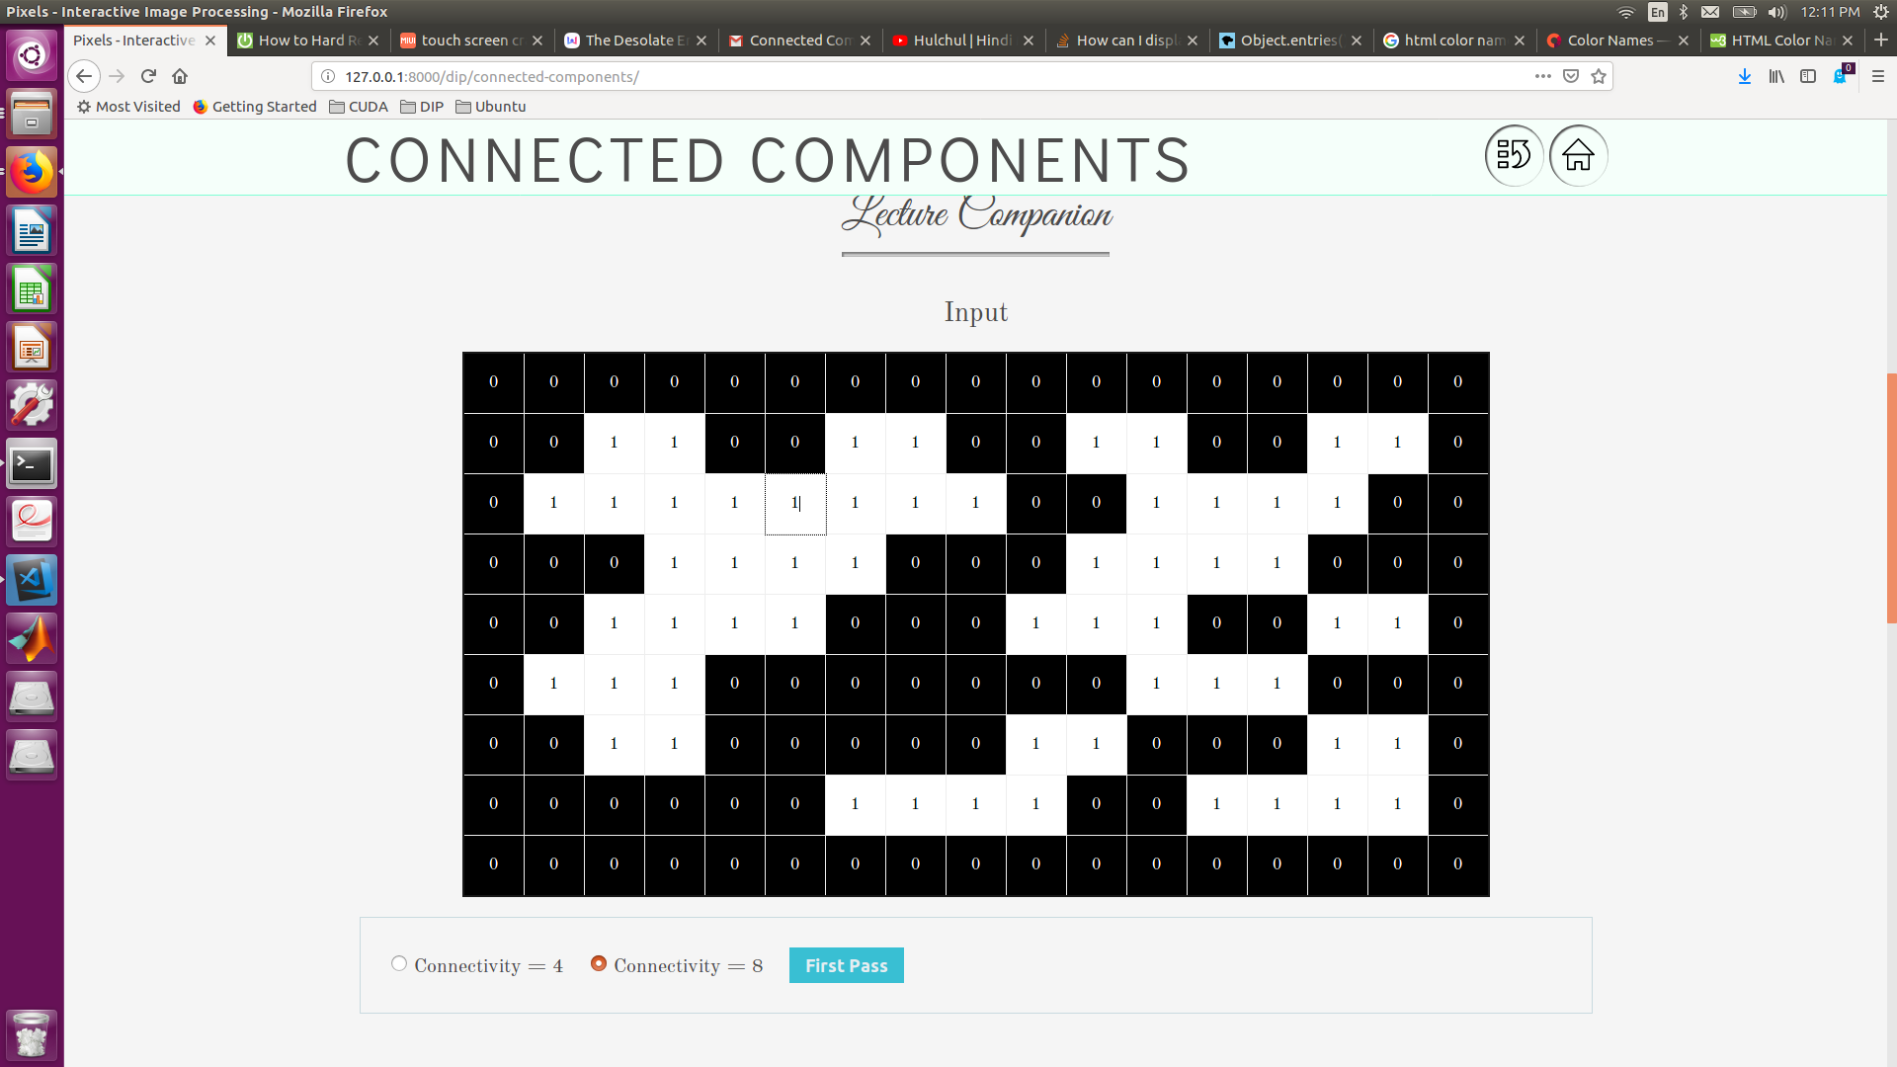

User can choose between Connectivity 8 or 4 and then clicking on First Pass generates the First Pass (see below)

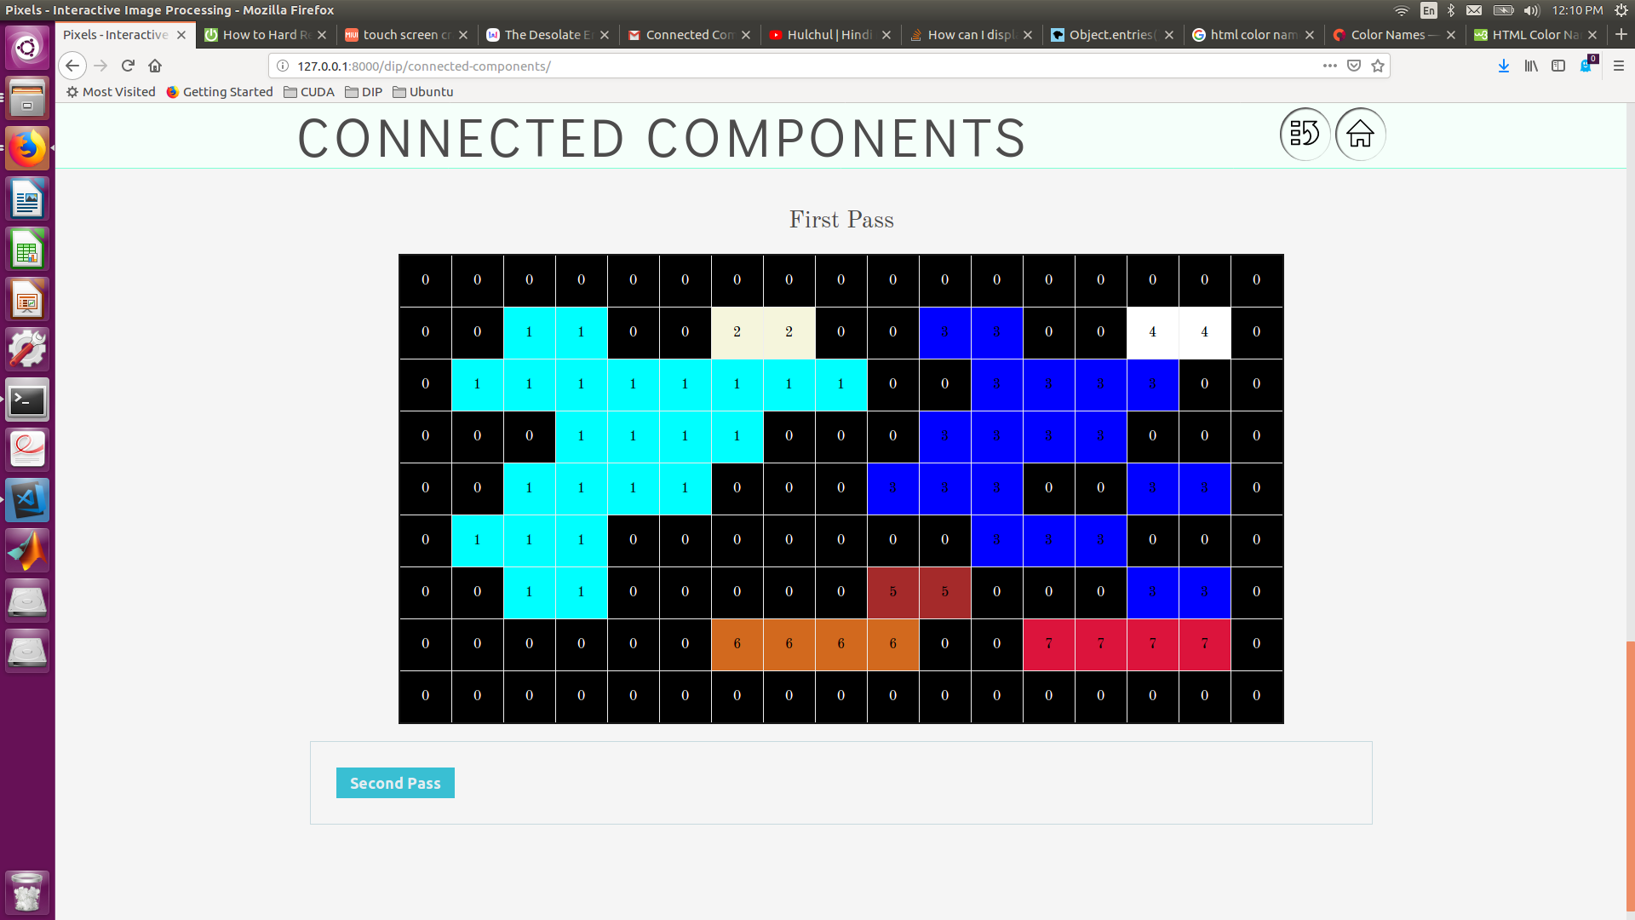

Clicking on the Second Pass Button Generates the Second Pass (see below)

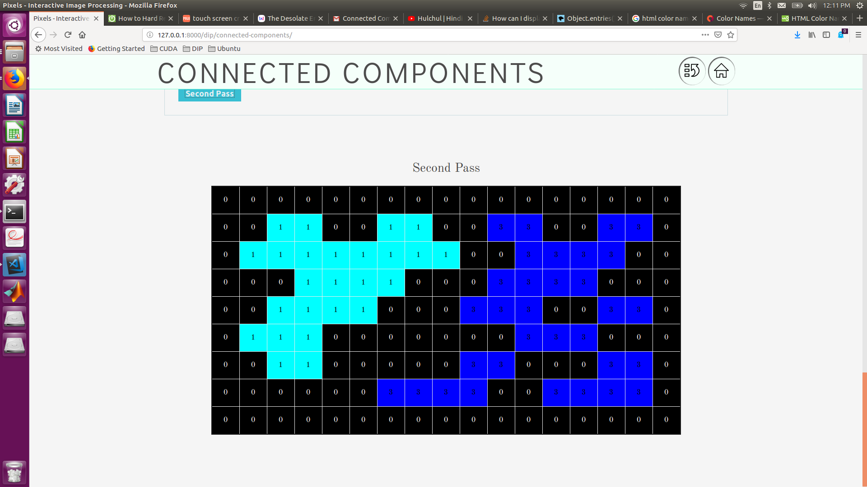

## Image Processing Techniques Inventory

* Histograms
* Histogram Plot
* Histogram Equalization
* Image Thresholding
* Global Thresholding
* Adaptive Thresholding
* Otsu’s Binarization
* Sharpening Spatial Filters
* Sobel Derivatives
* Laplacian Derivatives
* Smoothing Spatial Filters
* Averaging Filter
* Gaussian Filter
* Median Filter
* Bilateral Filter
* Morphological Transformations
* Connected Components
* Erosion
* Dilation
* Opening
* Closing

# Application Architecture and Development

## Folder structure

The folder structure for the project is as follows:

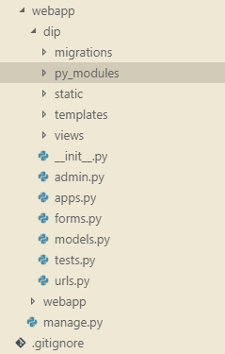

* **/webapp/dip/py_modules** : Contains the Python Implementation of Image Processing Modules
* **/webapp/dip/static**: Contains the static assets like CSS, JS for the website. It is further subdivided in to **css/** and **js/** and **fonts/** folders
* **/webapp/dip/templates**: Contains the Web Page Django Templates for the Image Processing Modules
* **/webapp/dip/views**: Contains the view controller logic python scripts for the Image Processing Modules
* **Urls.py :** This file contains the URL settings and view bindings for the Modules

Above mentioned are the folders and files that the developer needs to develop for if the application needs

to be extended.

# Results

## histogram plot

GreyScale

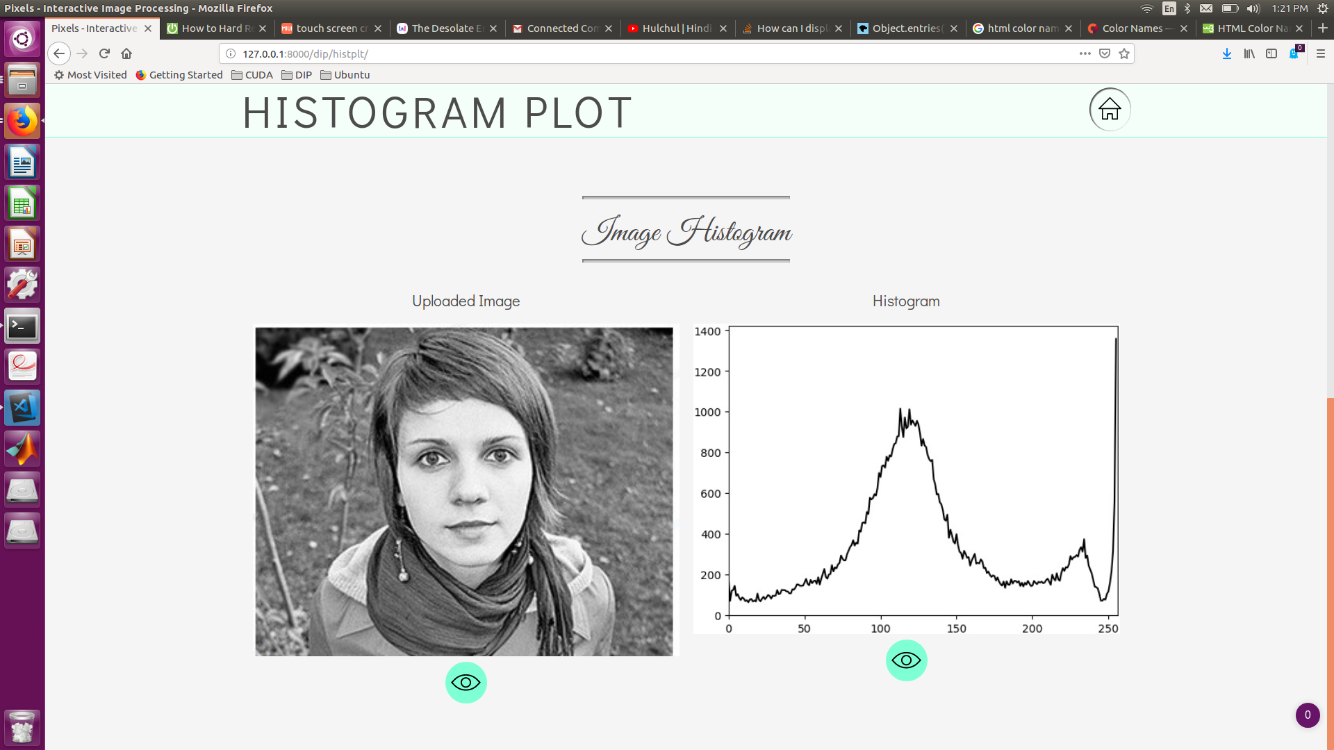

Color

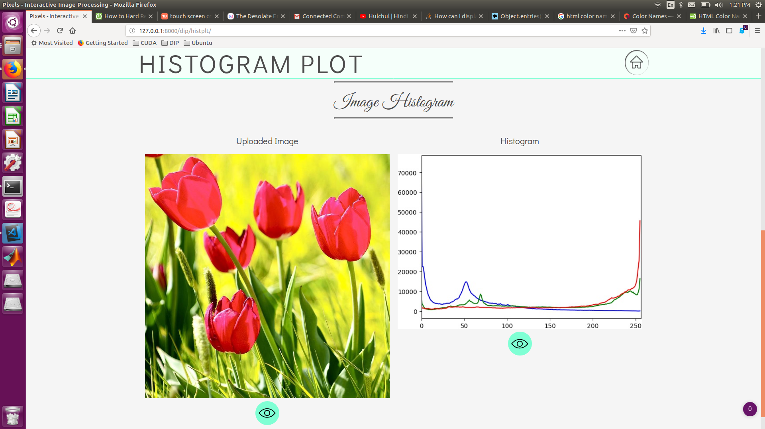

## histogram Equalisation

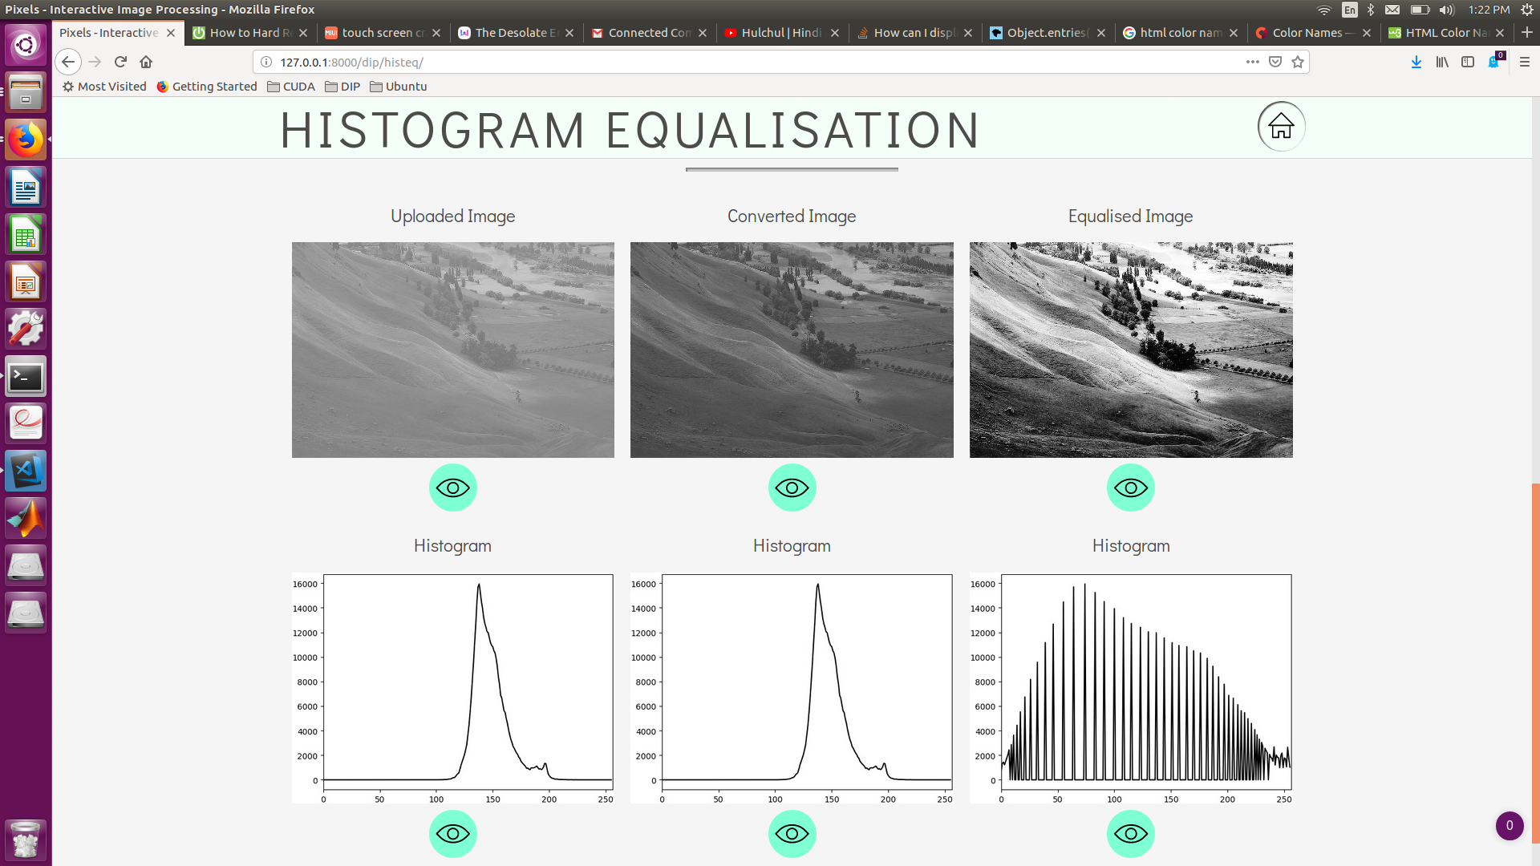

## global thresholding

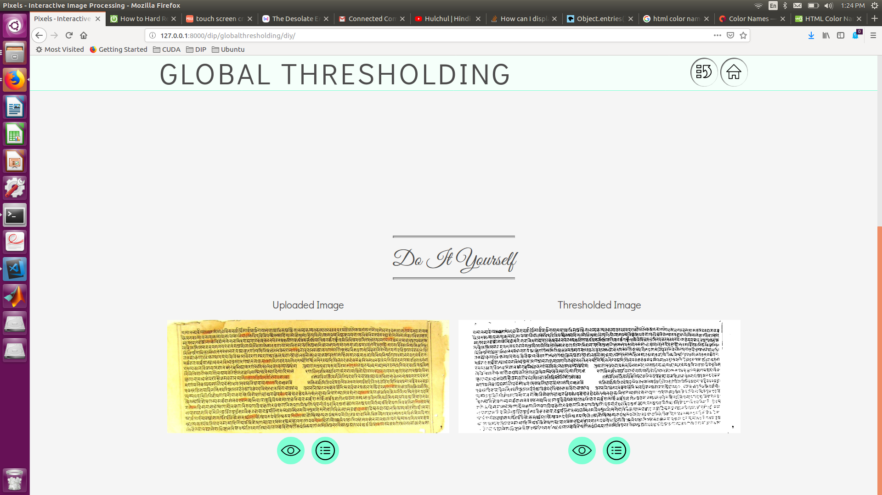

## adaptive thresholding

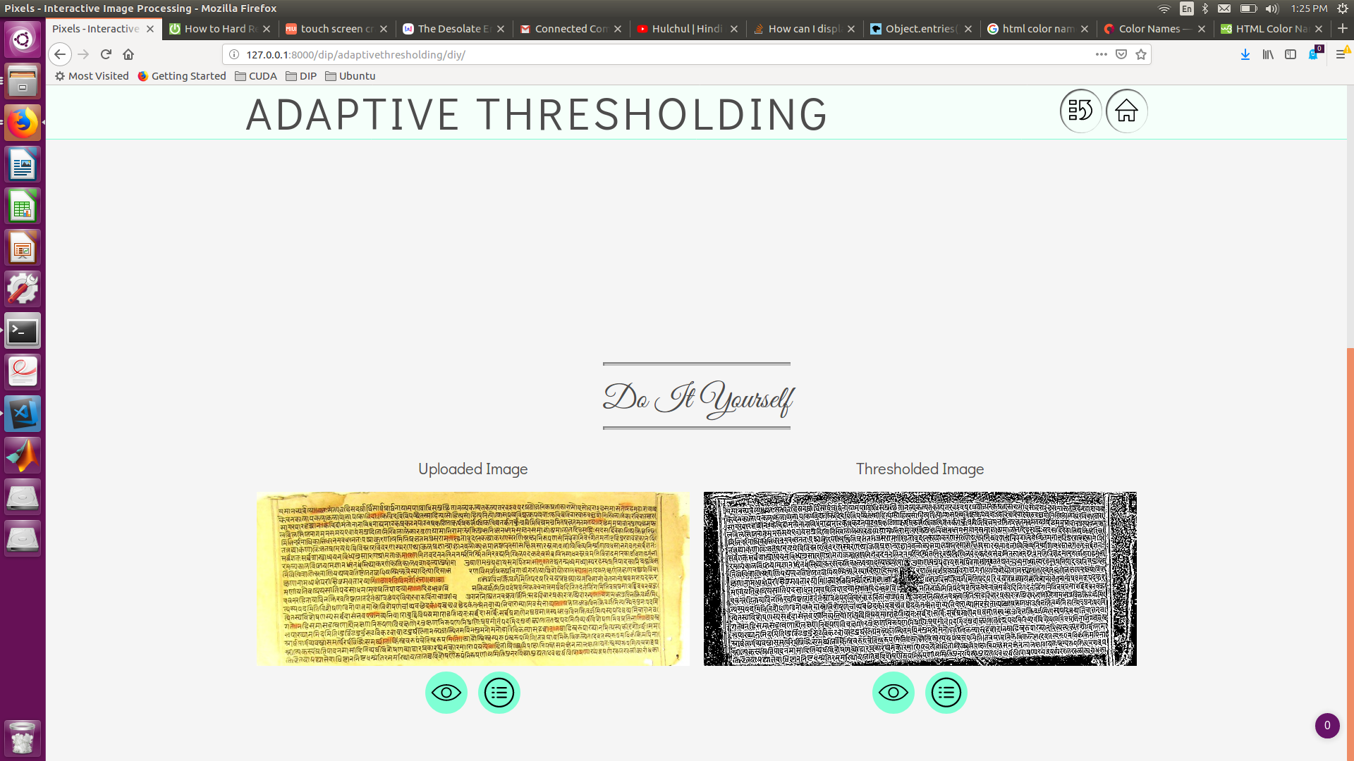

## average filter

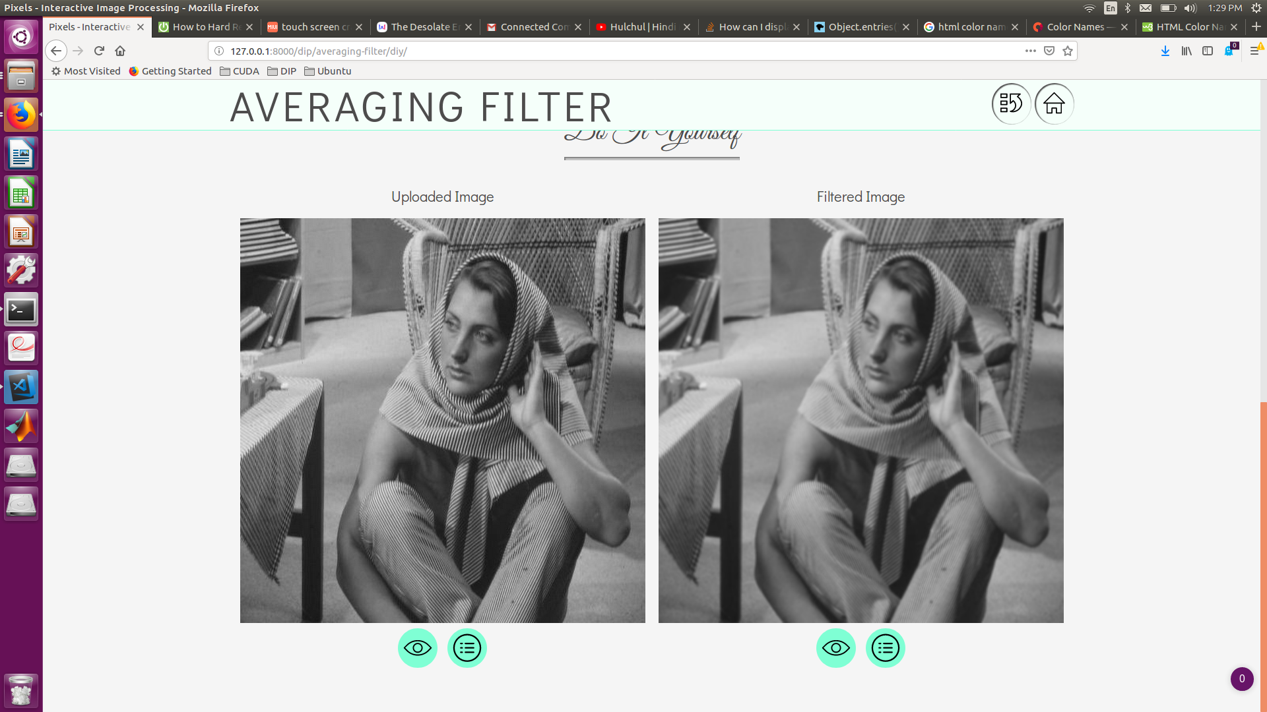

## gaussian filter

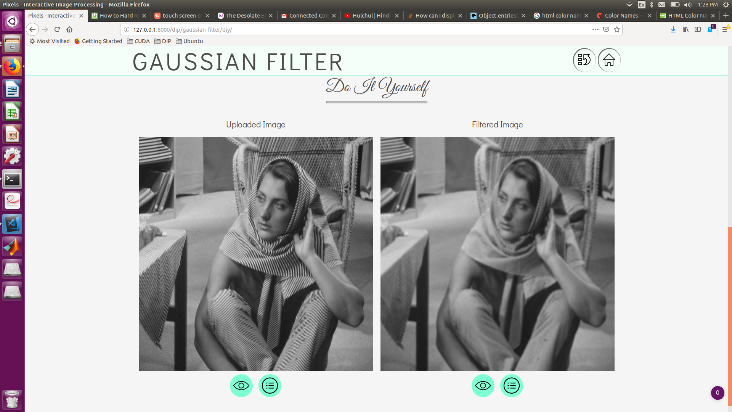

## median filter

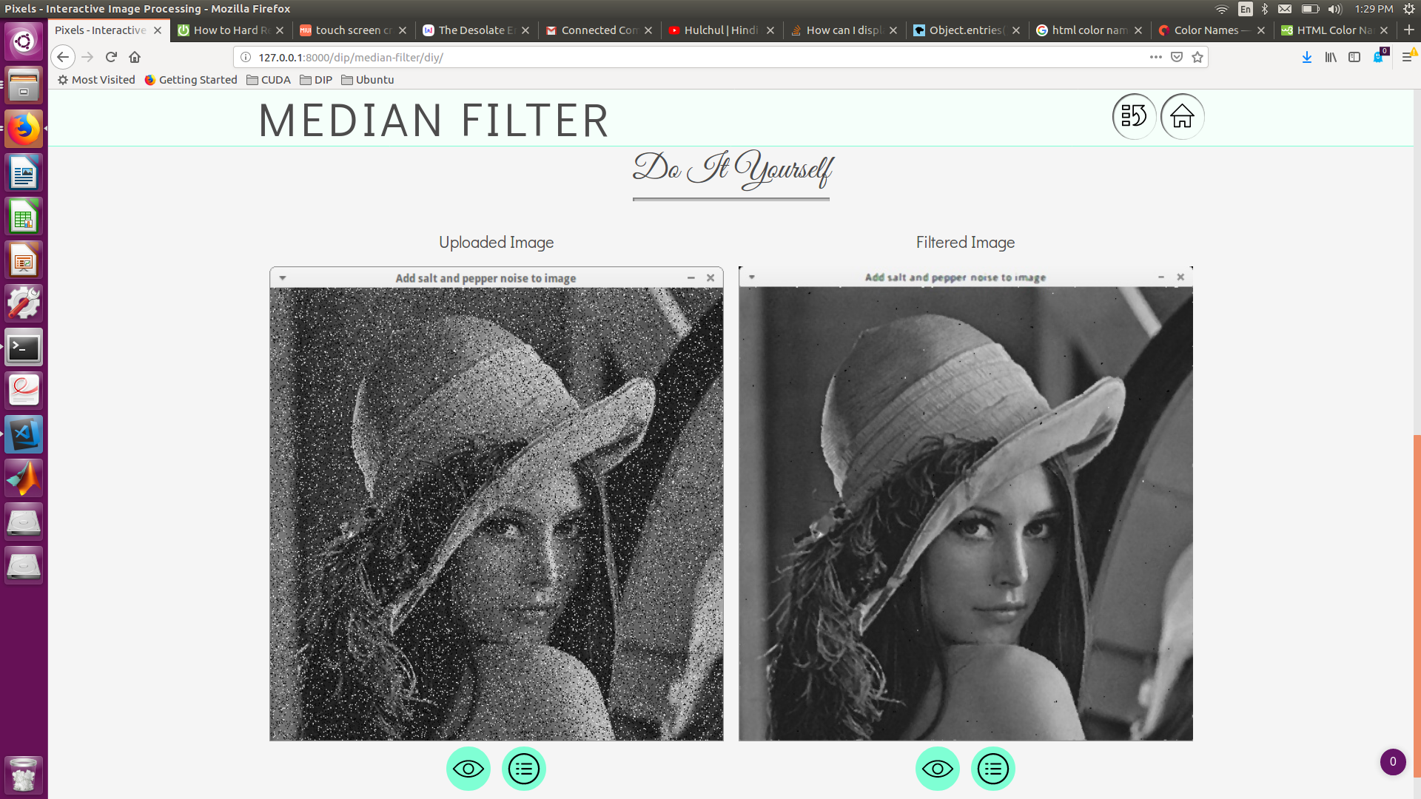

## bilateral filter

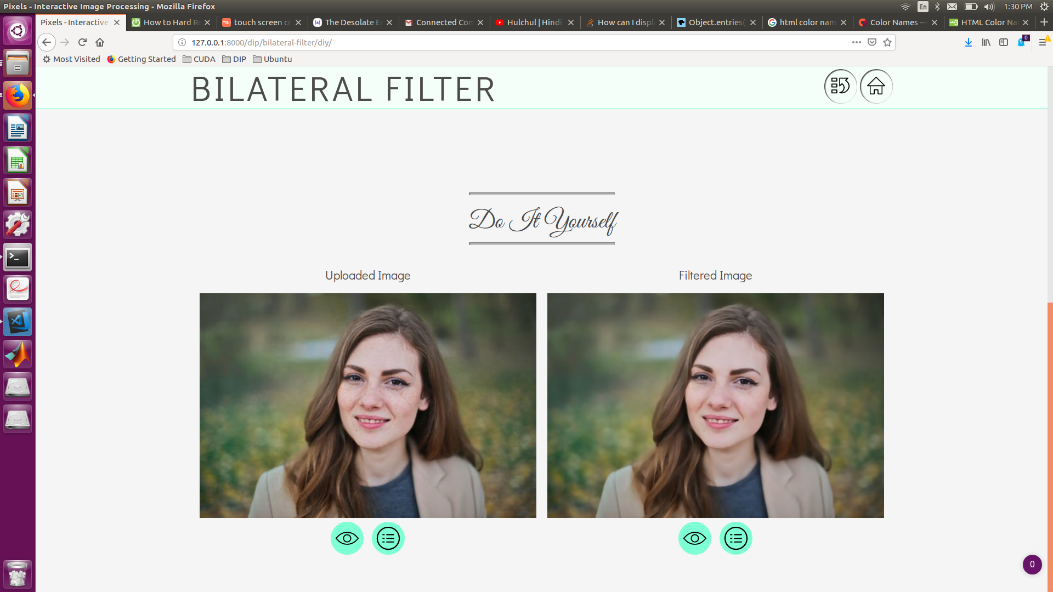

## sobel filter

90 Degrees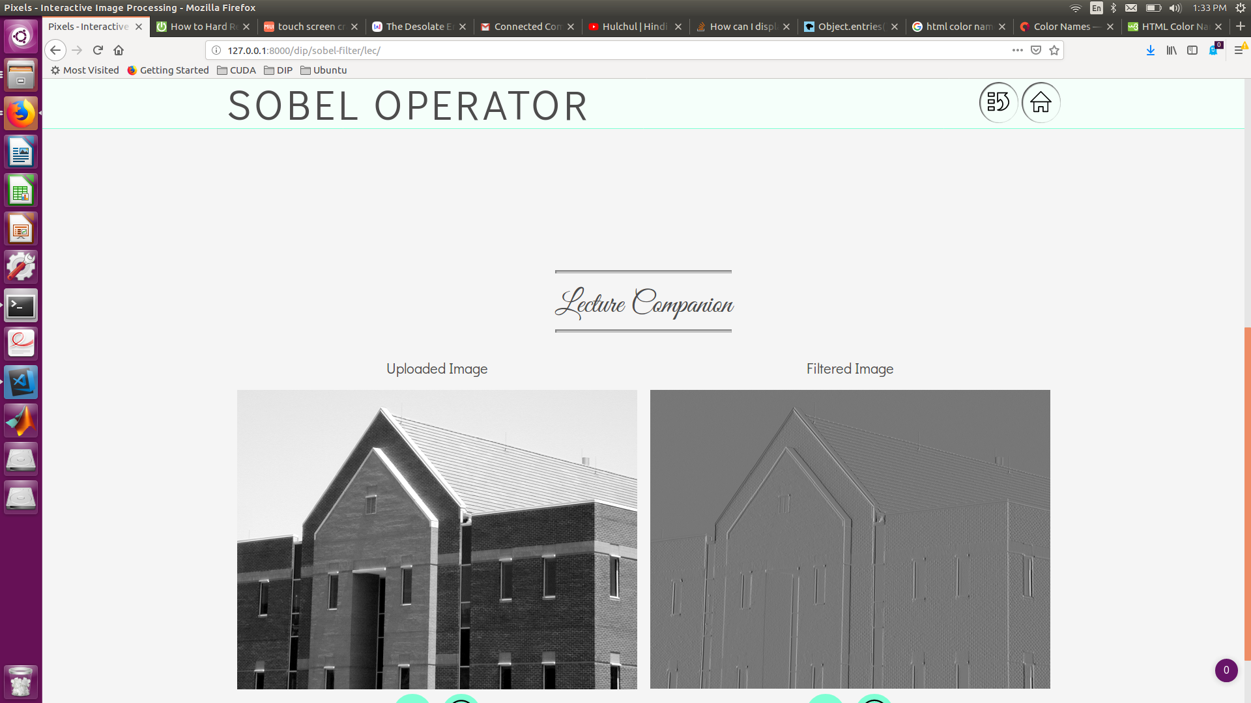

0 Degree

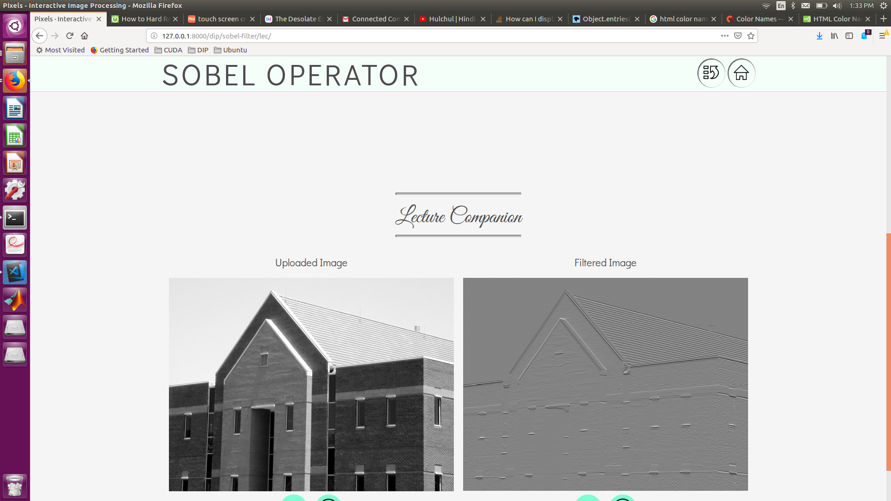

-45 Degree

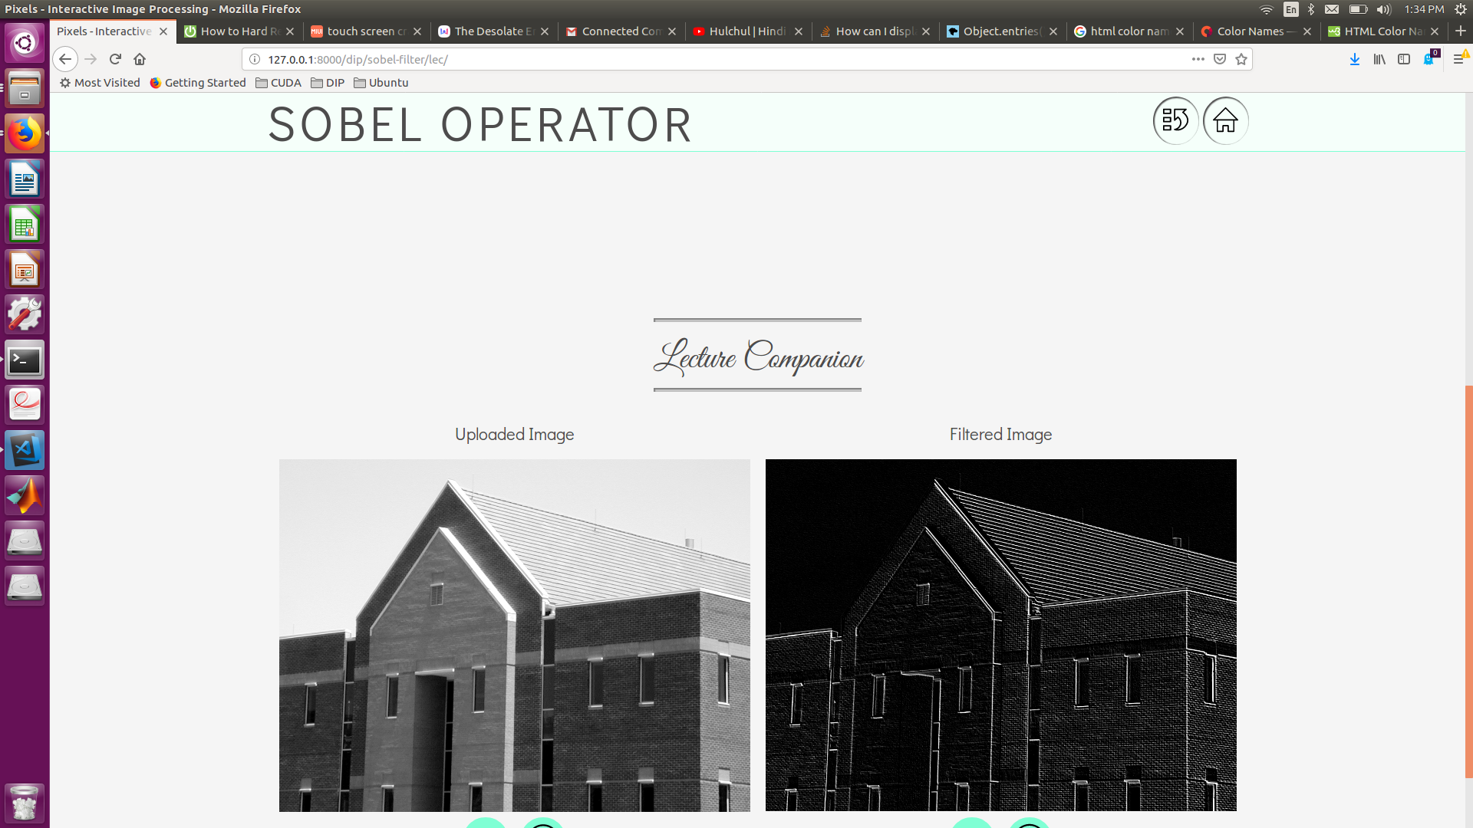

+45 Degree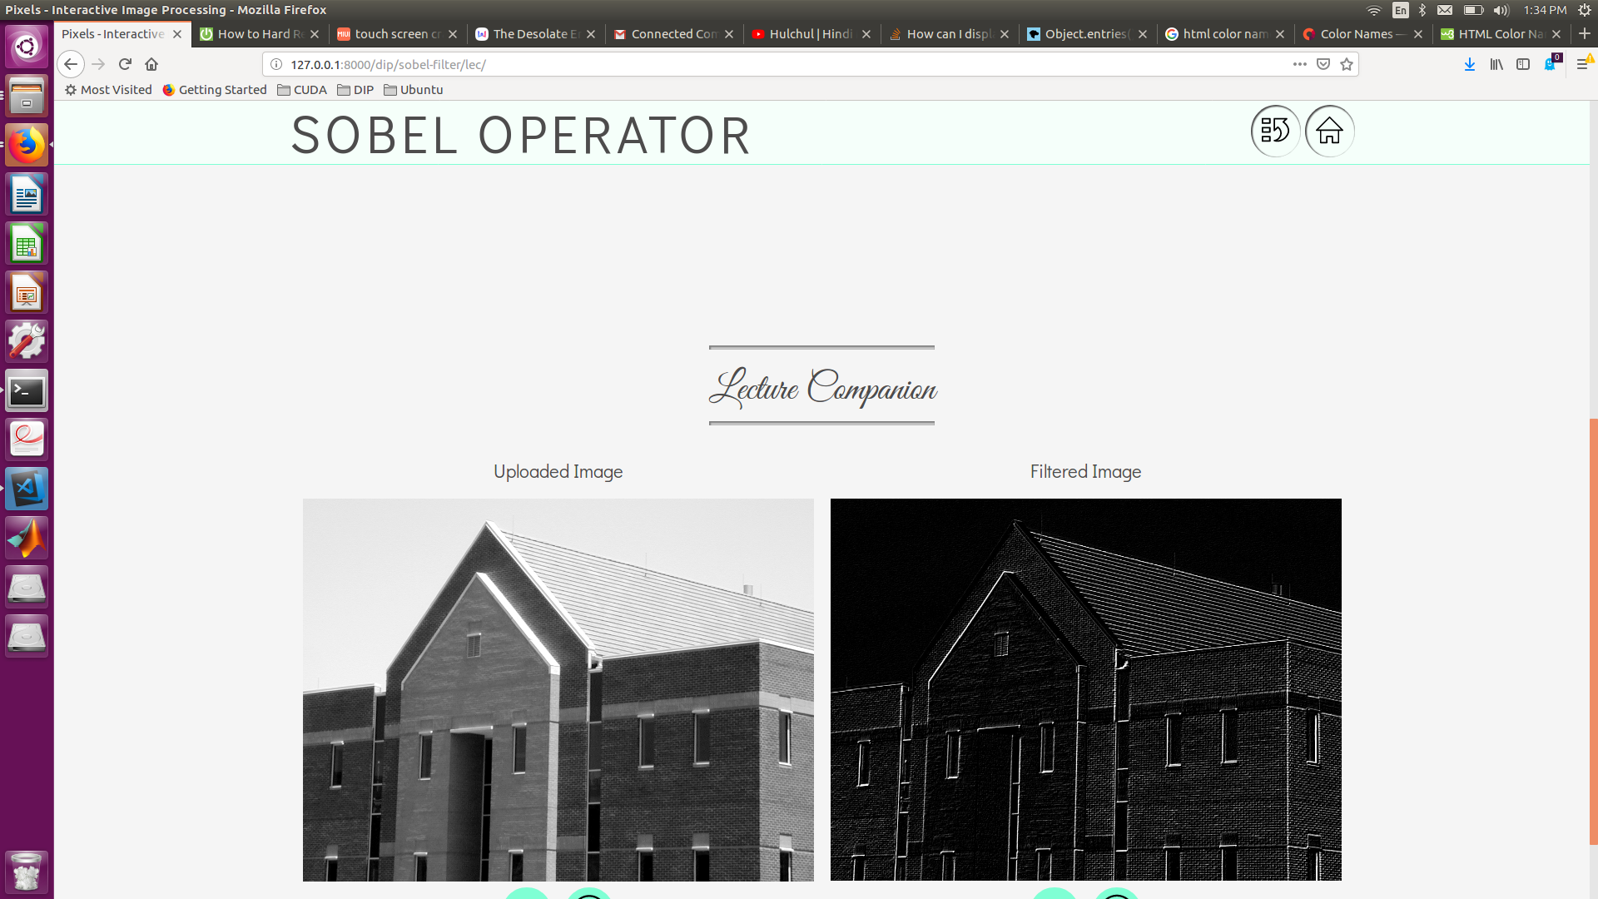

Magnitude

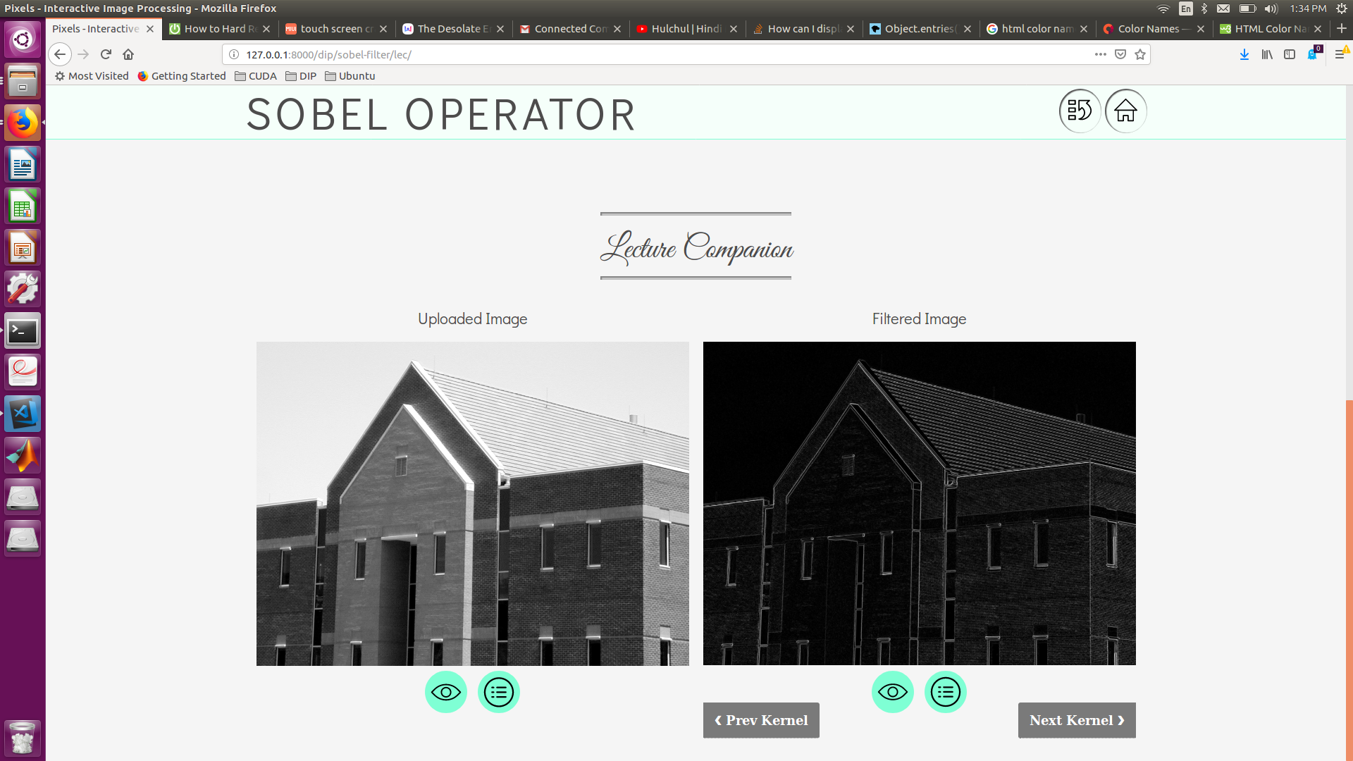

Angle

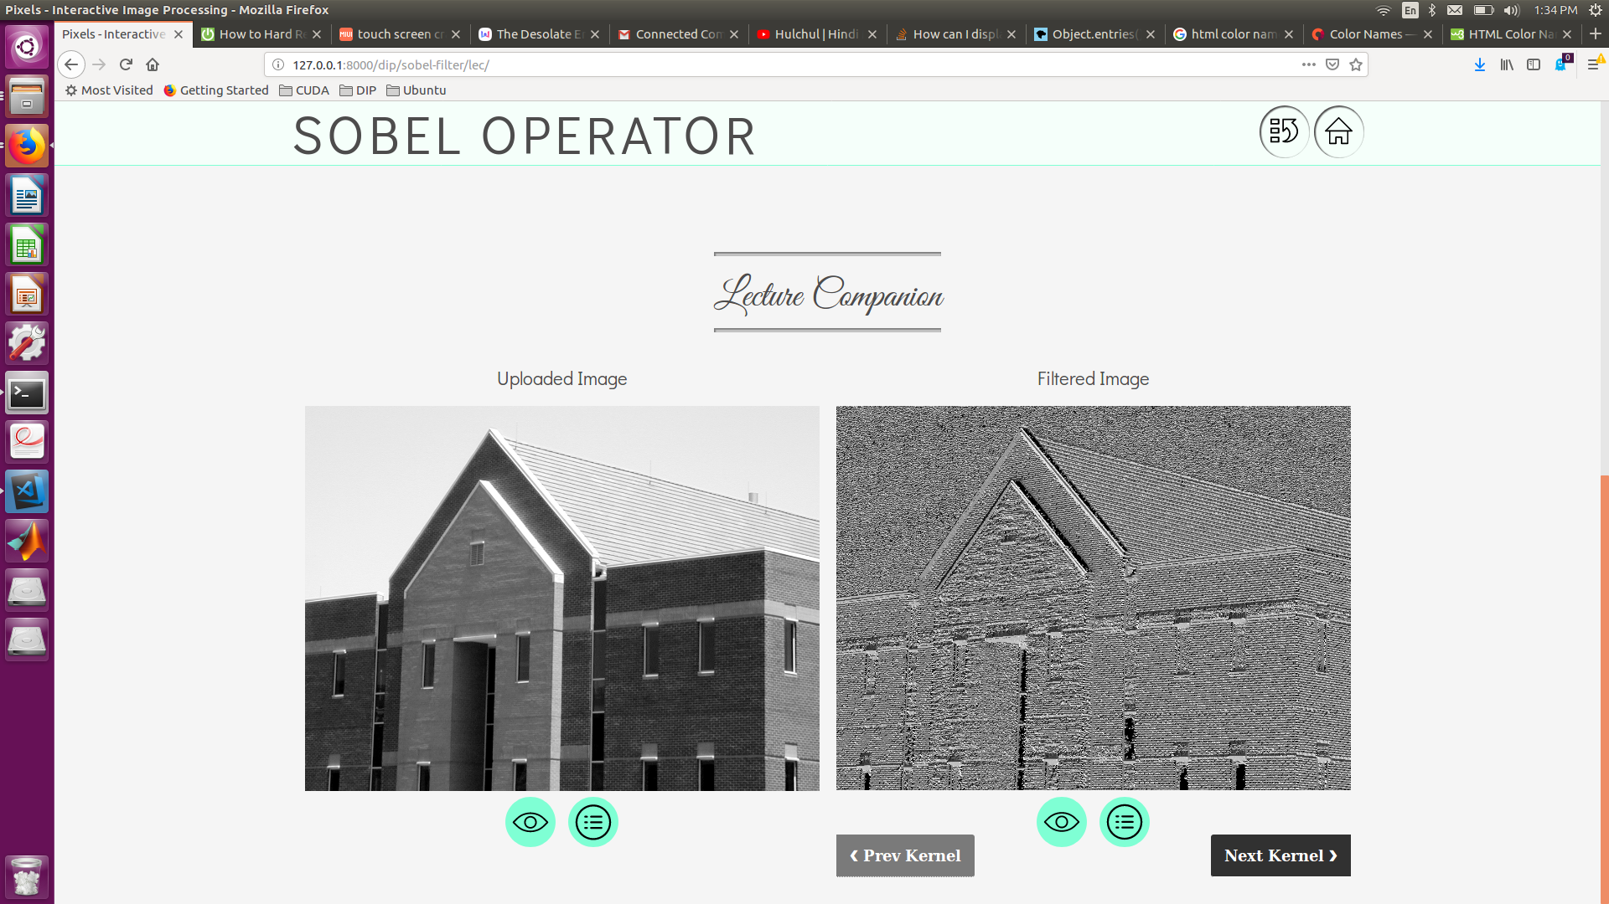

## connected components

See before

## erosion

See before

## dilation

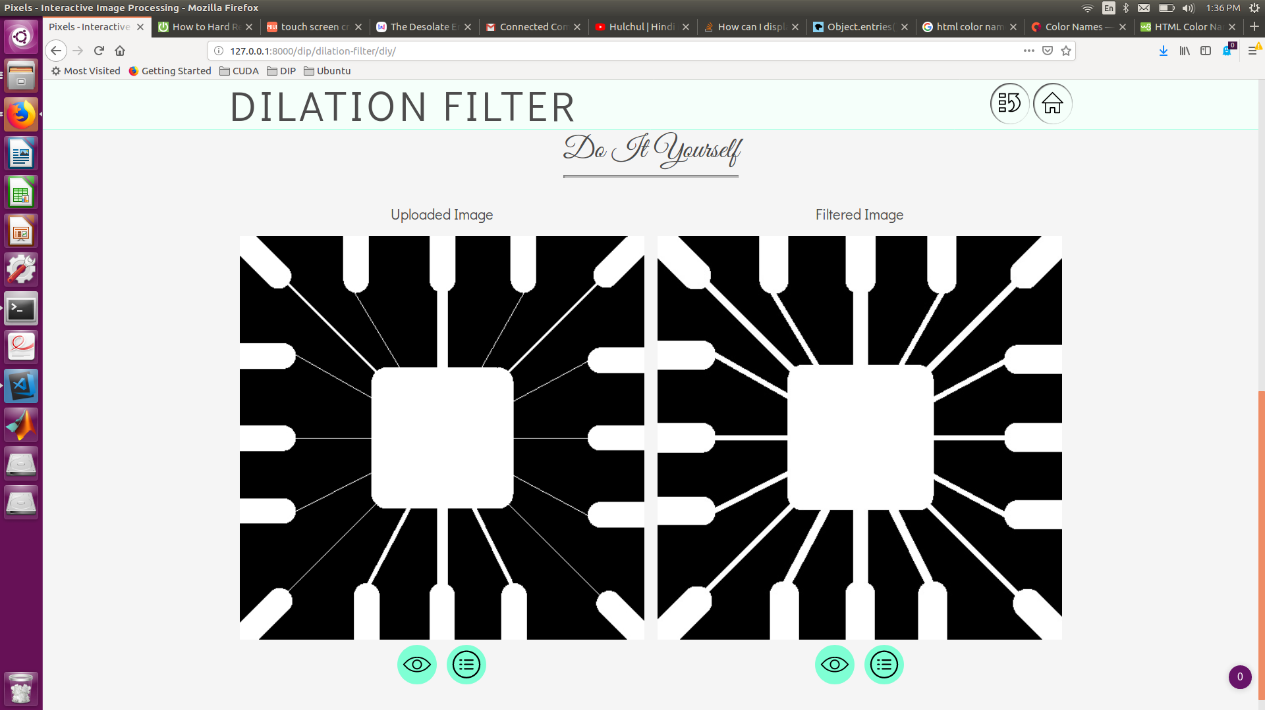

# Team Members

|  |  |  |  |
| --- | --- | --- | --- |
| Lokesh balani  20173073 PGSSP, IIITH |  | abhishek tyagi  20173067 pgssp, iiith |  |
|  |  |  |  |

# Project Milestones and Contribution

## PROJECT milestones

* Basic Django Platform Setup
* UX & Design for the Web Application
* Developing Front End (CSS/JS)
* Image Drag & Drop, Select Zoom Support
* Back End Support for Python Libraries
* Implementing Image Processing Techniques
* Support for Configurable Options
* Division of View
* Instructors’ Lecture Companion
* DIY (Do It Yourself)

## contribution - lokesh

* Basic Django Platform Setup
* UX & Design for the Web Application
* Developing Front End (CSS/JS)
* Image Drag & Drop, Select Zoom Support
* Support for Configurable Options
* Implementing Image Processing Techniques
* Histogram
* Connected Components, First Pass & Second Pass with Union Find - JavaScript
* Division of View
* Instructors’ Lecture Companion
* DIY (Do It Yourself)

## contribution - ABHIshek

* UX & Design for the Web Application
* Back End Support for Python Libraries
* Implementing Image Processing Techniques
* Morphological
* Smoothing Spatial Filters
* Sharpening Spatial Filters (Laplacian & Sobel)
* Image Thresholding
* Connected Components, First Pass & Second Pass with Union Find - Python